Karnatak Law Society’s

GOGTE INSTITUTE OF TECHNOLOGY

Udyambag Belagavi -590008

Karnataka, India.



A Course Project Report on

**“Application of Fourier Transforms”**

Submitted for the requirements of 3rd semester B.E. in CSE

for **“Statistical -Numerical- Fourier Techniques** (18MATCS31)**”**

**Submitted by**

|  |  |
| --- | --- |
| **NAME** | **USN** |
| **Shradha Mallikarjun Patil** | **2GI20CS144** |
| **Srushti B Mudennavar** | **2GI20CS158** |
| **Vijayalaxmi S Korti** | **2GI20CS178** |
|  |  |

**Under the guidance of**

**Dr. Mandakini A. Desurkar**

Asst. Professor, Department of Mathematics,

KLS Gogte Institute of Technology

Karnatak Law Society’s

GOGTE INSTITUTE OF TECHNOLOGY

Udyambag Belagavi -590008

Karnataka, India.

Department of Mathematics

Academic Year 2021-2022 (Odd semester)



**Certificate**

This is to certify that the Course Project work titled **“Application of Fourier Transforms”** for **“Statistical -Numerical- Fourier Techniques** (18MATCS31)**”**carried out by Students: SHRADHA MALLIKARJUN PATIL (2GI20CS144), SRUSHTI B MUDENNAVAR (2GI20CS158), VIJAYALAXMI S KORTI (2GI20CS178) have submitted in partial fulfilment of the requirements for 3rd semester B.E. in COMPUTER SCIENCE AND ENGINEERING, Visvesvaraya Technological University, Belagavi. It is certified that all corrections/suggestions indicated have been incorporated in the report. The course project report has been approved as it satisfies the academic requirements prescribed for the said degree.

Date:28-01-2022 Signature of Guide

Place: Belagavi Dr. Mandakini A. Desurkar

Asst. Professor, Dept. of Mathematics,

KLS Gogte Institute of Technology,

Belagavi.

MARKS ALLOCATION:

|  |  |  |  |  |  |
| --- | --- | --- | --- | --- | --- |
|  | **Batch No.:** | | | | |
| 1. | Seminar Title: | Marks Range | **USN** | | |
| **2GI18CS144** | **2GI18CS158** | **2GI18CS178** |
| 2. | Abstract (PO2) | 0-2 |  |  |  |
| 3. | Application of the topic to the course (PO2) | 0-3 |  |  |  |
| 4. | Literature survey and its findings (PO2) | 0-4 |  |  |  |
| 5. | Methodology, Results and Conclusion  (PO1, PO3, PO4) | 0-6 |  |  |  |
| 6. | Report and Oral presentation skill (PO9, PO10) | 0-5 |  |  |  |
|  | Total | 20 |  |  |  |

*20 marks is converted to 10 marks for CGPA calculation

1.**Engineering Knowledge:** Apply the knowledge of mathematics, science, engineering fundamentals and an engineering specialization to the solution of complex engineering problems.

2.**Problem Analysis:** Identify, formulate, review research literature, and analyse complex engineering problems reaching substantiated conclusions using first principles of mathematics, natural sciences and Engineering sciences.

3.**Design/Development of solutions:** Design solutions for complex engineering problems and design system components or processes that meet the specified needs with appropriate consideration for the public health and safety, and the cultural, societal, and environmental considerations

4.**Conduct investigations of complex problems:** Use research-based knowledge and research methods including design of experiments, analysis and interpretation of data, and synthesis of the information to provide valid conclusions.

**5.Modern tool usage:** Create, select, and apply appropriate techniques, resources, and modern engineering and IT tools including prediction and modeling to complex engineering activities with an understanding of the limitations.

**6.The engineer and society:**Apply reasoning informed by the contextual knowledge to assess societal, health, safety, legal and cultural issues and the consequent responsibilities relevant to the professional engineering practice.

**7.Environment and sustainability:** Understand the impact of the professional engineering solutions in societal and environmental contexts, and demonstrate the knowledge of, and need

for sustainable development.

**8.Ethics:** Apply ethical principles and commit to professional ethics and responsibilities and norms of the engineering practice.

**9.Individual and team work:** Function effectively as an individual and as a member or leader in diverse teams, and in multidisciplinary settings.

**10.Communication:** Communicate effectively on complex engineering activities with the engineering community and with society at large, such as, being able to comprehend and write effective reports and design documentation, make effective presentations, and give and receive clear instructions.

**11. Project management and finance:** Demonstrate knowledge and understanding of the engineering management principles and apply these to one's own work, as a member and leader in a team, to manage projects and in multidisciplinary environments.

**12. Life-long learning:** Recognize the need for and have the preparation and ability to engage in independent and lifelong learning in the broadest context of technological change.

TABLE OF CONTENTS: PAGE NO:

1. Abstract 4
2. Introduction 4
3. Applications of Fourier Transforms 4
4. Circuit Analysis 5
5. Signal Analysis and processing 6
6. Image Processing using Fourier Transforms 7
7. Applications in MRI and CT 10
8. Conclusion 11
9. References 11

ABSTRACT:

Fourier Transform is useful in the study of solution of partial differential equation to solve initial boundary value problems. A Fourier Transform when applied to partial differential equation reduces the number of independent variables by one. We use Fourier Transform in signal &image processing. It is also useful in cell phones, LTI system & circuit analysis.

INTRODUCTION:

We obtain Fourier Transform by a limiting process of Fourier series. Since it was first used by French Mathematician Jean Baptiste Fourier (1768-1830) in a manuscript submitted to the Institute of France in 1807.He said that Fourier Transform is a mathematical procedure which transforms a function from time domain to frequency domain. Fourier analysis is useful in almost every aspect of the subject ranging from solving LDE to developing computer models , to the processing & analysis of data. The Fourier Transform is a magical mathematical tool that decomposes any function into the sum of sinusoidal basis functions. The Fourier Transform is a tool that breaks a waveform (a function or signal) into an alternate representation characterized by sine & cosines.

APPLICATIONS OF FOURIER TRANSFORM:

The Fourier Transform method is applicable in many fields of science & technology such as 1) Application to IBVP

2) Circuit Analysis

3) Signal Analysis

4) Cell phones

5) Image Processing

6) Signal Processing& LTI system

CIRCUIT ANALYSIS:

The Fourier series, which is a branch of Fourier analysis, decomposes periodic signals into sum of infinite trigonometrically series in sine and cosine terms. So, we are aiming to find an approximation using trigonometric functions for various waveforms like saw tooth, square wave, etc, that occur in electronics.

There are many linear circuits used in electronic engineering field. These circuits include various components like capacitor, inductor, resistor etc. Every Electronic circuit can be modelled using mathematical equations.

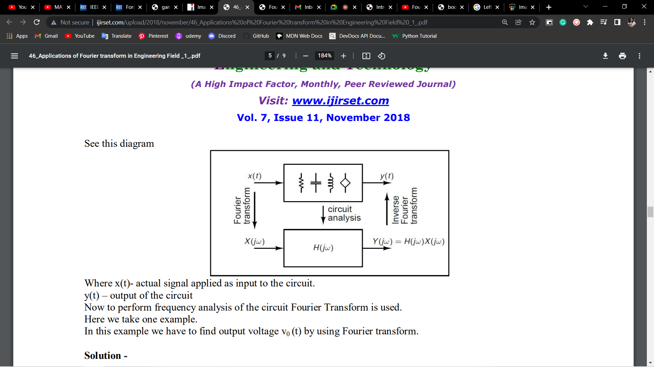

Where x(t)- actual signal applied as input to the circuit. y(t) – output of the circuit

Let’s take an example

In this example we have to find output voltage v0 (t) by using Fourier transform.

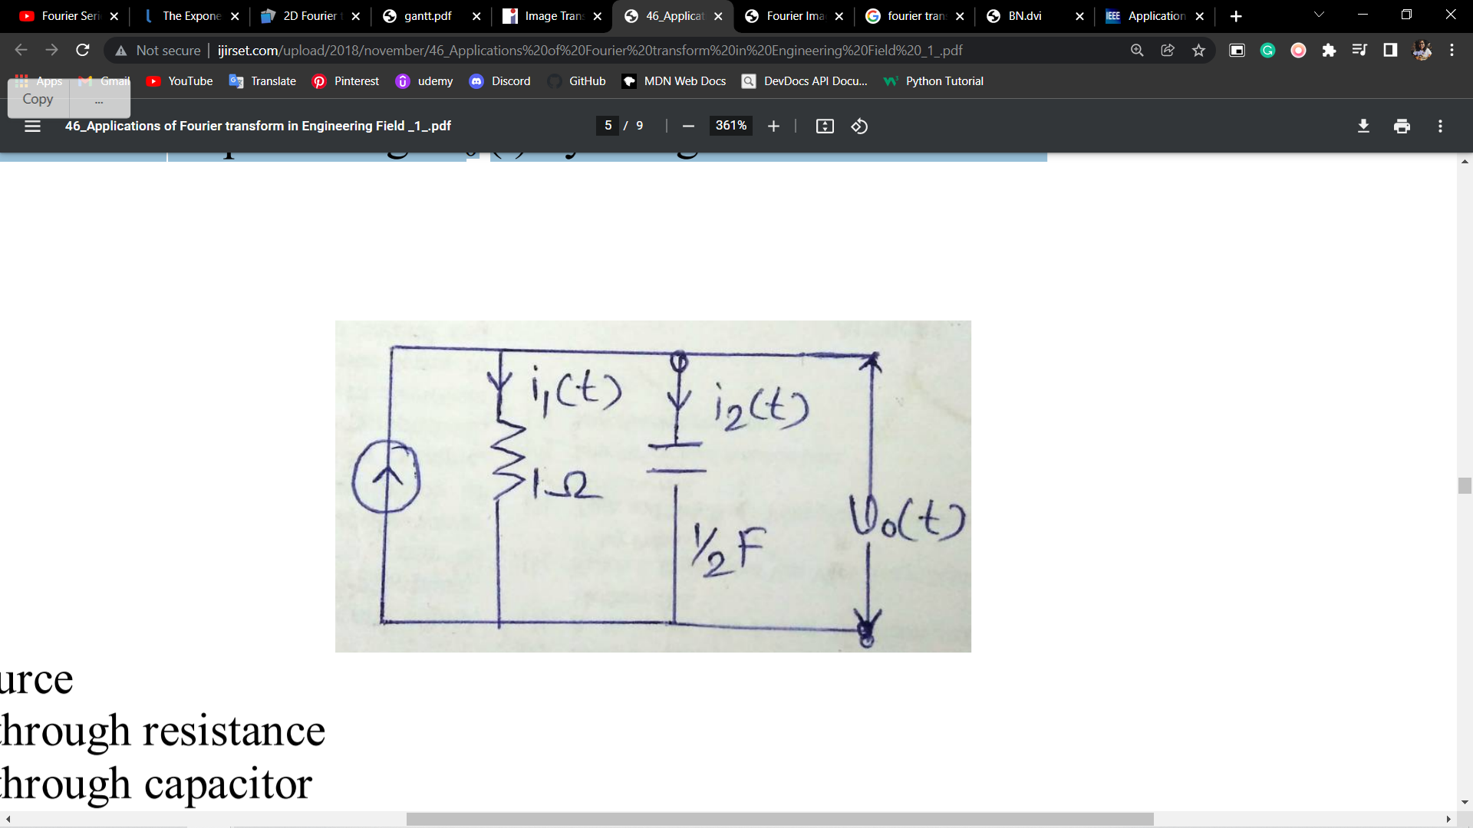

Solution –

Where i(t) = current source

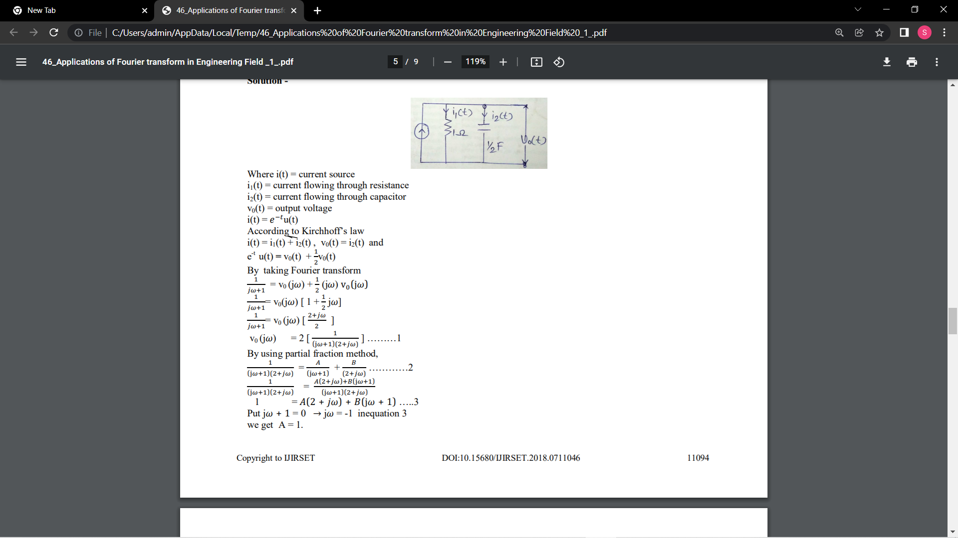

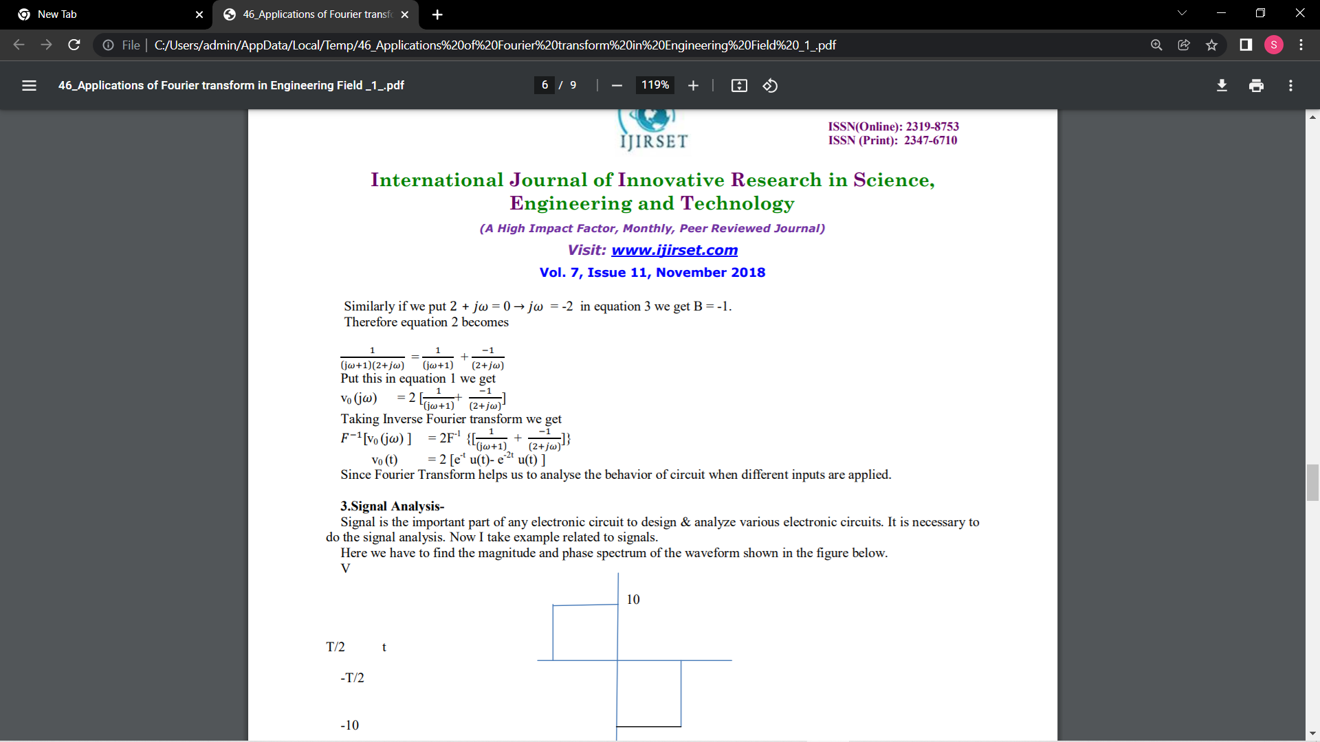

Since Fourier Transform helps us to analyse the behaviour of circuit when different inputs are applied.

SIGNAL PROCESSING AND LTI SYSTEM:

Signal can be defined as a variability of any physical value, that can be described as a function of a single or multiple arguments. Let us consider one-dimensional time functions.

In real world, time functions that can be met are placed in continuous domain.

However, the development of computer science, caused that analog signal processing became rare. It is much more cost-effective to create, implement and test signal processing algorithms in digital world, then to project and develop analog (electronic) devices.

The Fourier Transform is extensively used in the field of Signal Processing. In fact, the Fourier Transform is probably the most important tool for analyzing signals in that entire field.

A signal is any waveform (function of time). This could be anything in the real world - an electromagnetic wave, the voltage across a resistor versus time, the air pressure variance due to your speech (i.e. a sound wave), or the value of Apple Stock versus time. Signal Processing then, is the act of processing a signal to obtain more useful information, or to make the signal more useful.

Suppose we have a box that accepts an input signal and produces an output signal from that. Such a box can be thought of as a system:

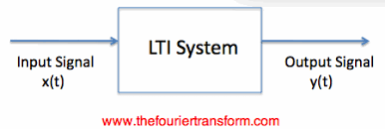

A System which takes an input signal and produces and output signal when we view the Fourier Transform of the output, we now know how the system reacts to every possible frequency. The reason for this goes back to the linearity of the Fourier Transform: the impulse in time can be thought of as an infinite sum of sinusoids at every possible frequency. The output result then is the sum of the responses to each frequency. Fourier Transform visualize the effect of an LTI system simple and the analysis much easier. The Fourier Transform is extensively used in LTI system theory, filtering and signal processing. In fact, the majority of the analysis takes place in the frequency domain, making the understanding of Fourier Theory indispensable.

A Problem with the Fourier Transform that Fourier analysis is performed on short intervals that are shifted and scaled to the interval [0, 2π]. While this method is helpful in understanding the short time behaviour of the signal of interest, we are sometimes interested in frequency behaviour on longer time scales. Therefore, an alternate method called windowing is necessary.

IMAGE PROCESSING USING FOURIER TRANSFORMS:

The Fourier Transform is an important image processing tool which is used to decompose an image into its sine and cosine components. The output of the transformation represents the image in the *Fourier* or frequency domain, while the input image is the spatial domain equivalent. In the Fourier domain image, each point represents a particular frequency contained in the spatial domain image.

Taking the Fourier transform of an image converts the straightforward information in the spatial domain into a scrambled form in the frequency domain.

The greatest advantage comes when considering the symmetries of the Fourier transform, allowing us to perform fewer computations for the forward and inverse transforms. Some of these symmetries, along with memory-management techniques, allow a far more computationally efficient algorithm for computing the Fourier transform on discrete data sets

The definitions of the transform (to expansion coefficients) and the inverse transform are given below:

F(u,v) = SUM{ f(x,y)*exp(-j*2*pi*(u*x+v*y)/N) }

and

f(x,y) = SUM{ F(u,v)*exp(+j*2*pi*(u*x+v*y)/N) }

where u = 0,1,2,...,N-1 and v = 0,1,2,...,N-1

x = 0,1,2,...,N-1 and y = 0,1,2,...,N-1

j = SQRT( -1 )

and SUM means double summation over proper

x,y or u,v ranges

## How It Works

As we are only concerned with digital images, we will restrict this discussion to the Discrete Fourier Transform (DFT).

The DFT is the sampled Fourier Transform and therefore does not contain all frequencies forming an image, but only a set of samples which is large enough to fully describe the spatial domain image. The number of frequencies corresponds to the number of pixels in the spatial domain image, i.e. the image in the spatial and Fourier domain are of the same size.

For a square image of size N×N, the two-dimensional DFT is given by:

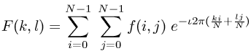

where f(a,b) is the image in the spatial domain and the exponential term is the basis function corresponding to each point F(k,l) in the Fourier space. The equation can be interpreted as: the value of each point F(k,l) is obtained by multiplying the spatial image with the corresponding base function and summing the result.

The basis functions are sine and cosine waves with increasing frequencies, i.e. F(0,0) represents the DC-component of the image which corresponds to the average brightness and F(N-1,N-1) represents the highest frequency.

In a similar way, the Fourier image can be re-transformed to the spatial domain. The inverse Fourier transform is given by:

Eqn:eqnfour2

Note the Eqn:oneovern2 normalization term in the inverse transformation. This normalization is sometimes applied to the forward transform instead of the inverse transform, but it should not be used for both.

To obtain the result for the above equations, a double sum has to be calculated for each image point. However, because the Fourier Transform is separable, it can be written as

Eqn:eqnfour3

where

Eqn:eqnfour4

Using these two formulas, the spatial domain image is first transformed into an intermediate image using N one-dimensional Fourier Transforms. This intermediate image is then transformed into the final image, again using N one-dimensional Fourier Transforms. Expressing the two-dimensional Fourier Transform in terms of a series of 2N one-dimensional transforms decreases the number of required computations.

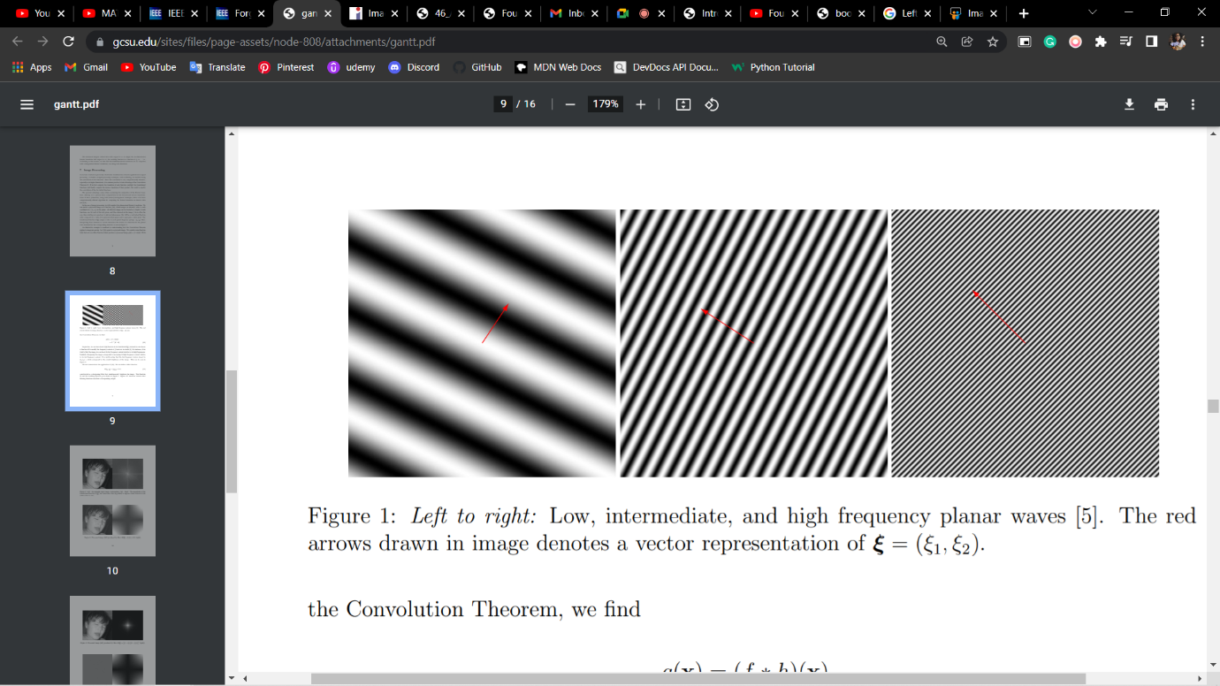

Even with these computational savings, the ordinary one-dimensional DFT has Eqn:eqnfour6 complexity. This can be reduced to Eqn:eqnfour5 if we employ the Fast Fourier Transform (FFT) to compute the one-dimensional DFTs. This is a significant improvement, in particular for large images. There are various forms of the FFT and most of them restrict the size of the input image that may be transformed, often to Eqn:eqnfour7 where n is an integer. The mathematical details are well described in the literature.

The Fourier Transform produces a complex number valued output image which can be displayed with two images, either with the real and imaginary part or with magnitude and phase. In image processing, often only the magnitude of the Fourier Transform is displayed, as it contains most of the information of the geometric structure of the spatial domain image. However, if we want to re-transform the Fourier image into the correct spatial domain after some processing in the frequency domain, we must make sure to preserve both magnitude and phase of the Fourier image.

The Fourier domain image has a much greater range than the image in the spatial domain. Hence, to be sufficiently accurate, its values are usually calculated and stored in float values.

APPLICATIONS IN MRI AND CT:

There are many physical processes which can be modelled with a convolution that we may wish undo through solving such an inverse problem. A simple one-dimensional case is the reconstruction of an audio signal that has been corrupted by noise or other artifacts. In imaging, we may wish to correct a photograph that was taken out-of-focus.

Fourier transform is integral to all modern imaging, and is particularly important in MRI. The signal received at the detector (receiver coils in MRI, piezoelectric disc in ultrasound and detector array in CT) is a complex periodic signal made of a large number of constituent frequencies (i.e., bandwidth). This can be visualized as multiple sine and or cosine waves along a time-axis. Fourier transform represents the same data over a frequency-axis. A common example is the MR spectroscopy image in which different molecules are at different frequencies along the x-axis.

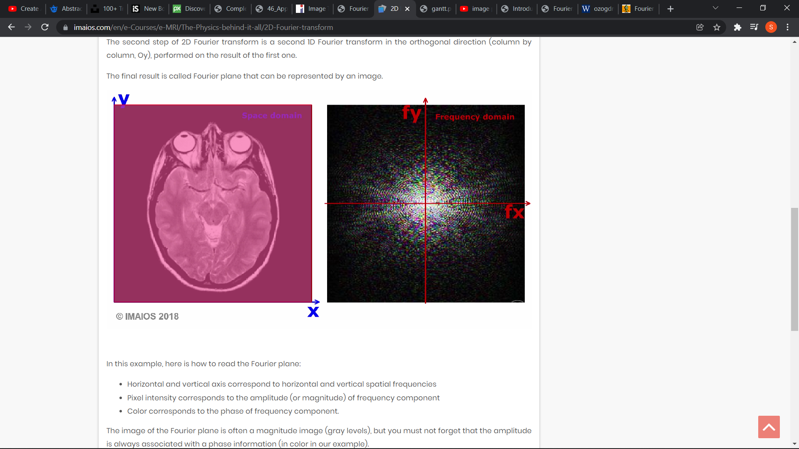

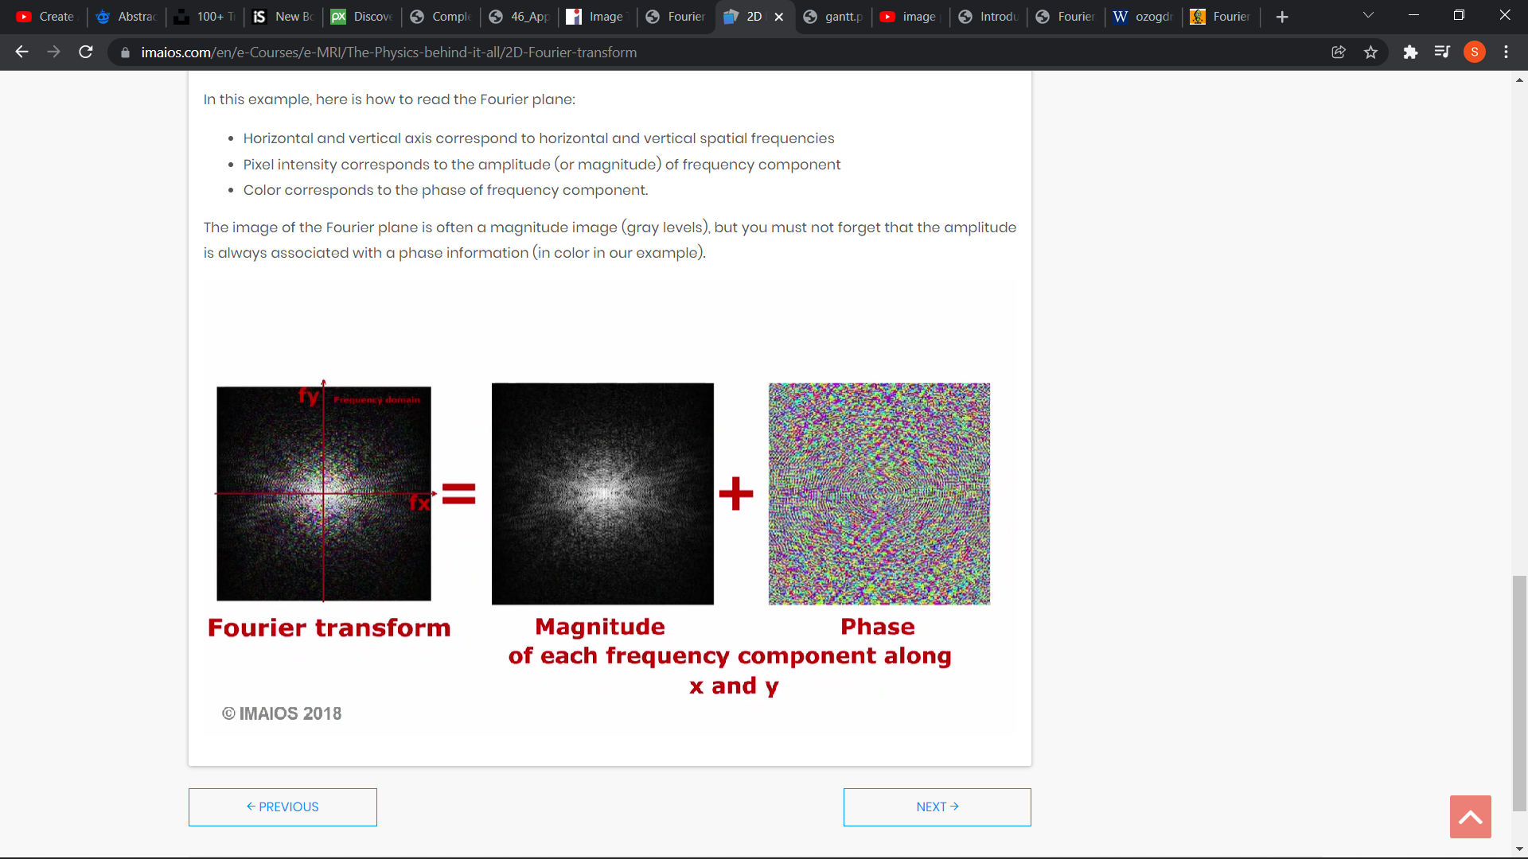

CONCLUSION:

The Fourier Transform is useful in many applications ranging from experimental instruments to rigorous mathematical analysis techniques. Thanks to modern developments in digital electronics, coupled with numerical algorithms such as the FFT, the Fourier Series has become one of the most widely used and useful mathematical tools available to any scientist.

REFERENCES:

B.S. Grewal – Higher Engineering Mathematics, Khanna Publishers, 42nd Edition, 2012 and onwards

[MRI image formation](https://www.imaios.com/en/e-Courses/e-MRI/The-Physics-behind-it-all)

<https://www.imaios.com/en/e-Courses/e-MRI/The-Physics-behind-it-all/2D-Fourier-transform>

Fourier Transform Wikipedia

<https://en.wikipedia.org/wiki/Fourier_transform>